

**Department of Artificial Intelligence**

**College of Computer Science and Information Technology**

1. **Objectives**
2. Understanding Image Segmentation

**Due Date: Tuesday October 8, 2024 @ 11:59 PM**

**Late Submissions:**

* Q: Can I skip the lab and submit the solution?
  + You will receive a mark of **zero** if you do not attend the lab, even if you complete the exercise. Attending the labs is compulsory for evaluation. If you have a justified excuse, you may receive a partial mark depending on the circumstances. See the next question for information on late submissions.
* **Q:** If I submit it at 12:00am, you’ll still mark it, right?
  + **A:** 11:59pm and earlier is on time. Anything after 11:59pm is late. Anything late will **NOT** be probably marked. If I find you have a legitimate cause, you will be graded according to the following rules (24 hours after deadline 🡪 assignment is marked out of 75% only, 48 hours after deadline 🡪 assignment is marked out of 50% only, 74 hours after deadline 🡪 assignment is marked out of 25% only).

1. **Introduction**

# Image Segmentation helps to obtain the region of interest (ROI) from the image. It is the process of separating an image into different areas.

# What is RoI?

# **RoI** (Region of Interest) is a proposed region from the original image. We’re not going to describe how to extract those regions because there are multiple methods to do only that. The only thing we should know right now is there are multiple regions like that and all of them should be tested at the end.

# Sample RoIs: Here we have 4 different RoIs.

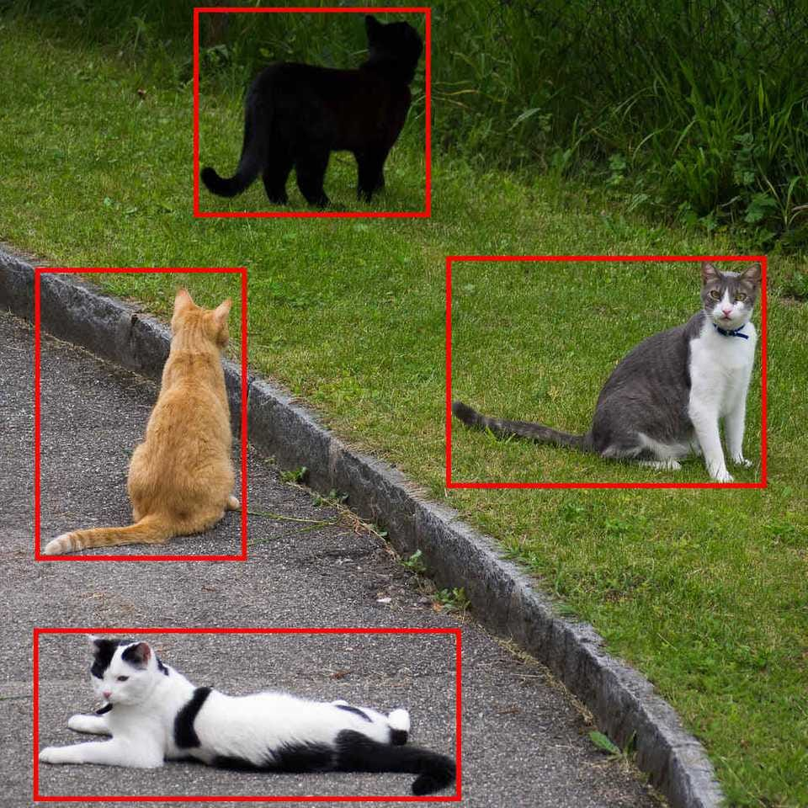

The goal of image segmentation is to simplify the image for better analysis. It is the process of assigning labels to every pixel in an image. Image segmentation has wide applications in Machine Learning, Computer Vision, AI, Medical imaging, Recognition tasks, Video surveillance, Object detection, etc. It impacts several domains, from healthcare to space science.

# Image segmentation

 Image Segmentation is essentially the process of partitioning a digital image into multiple segments to simplify and/or change the representation of an image into something that is more meaningful and easier to analyze.

In this lab, we will approach the Segmentation process as a combination of Supervised and Unsupervised algorithms.

**Supervised segmentation:** Some prior knowledge, possibly from human input, is used to guide the algorithm.

**Unsupervised segmentation**: No prior knowledge is required. These algorithms attempt to subdivide images into meaningful regions automatically. The user may still be able to tweak certain settings to obtain desired outputs.

# References

[1] P Soille. “Morphological Image Analysis, Principles and Applications”, 1999.

[2] R. C. Gonzalez, R. E. Woods, “Digital image processing”, 2nd ed. Upper Saddle River, N.J. Prentice Hall, 2002.

[3] P Chhikara, “Understanding Morphological Image Processing and Its Operations”, 2022, <https://towardsdatascience.com/understanding-morphological-image-processing-and-its-operations-7bcf1ed11756>

[4] [skimage.morphology — skimage 0.21.0 documentation (scikit-image.org)](https://scikit-image.org/docs/stable/api/skimage.morphology.html)

[5] Md. Zubair “Morphological Operations with Simulation (CV-05) ”, 2023